Customer Data Analysis Report
Project Code: PRDA – 04
Dataset: Shopping Data from 10 Istanbul Malls (2021–2023)
Tools Used: MS Excel for analysis and Power BI for Visualization.

1. Introduction
This project analyzes customer shopping behavior using transaction data collected from 10 shopping malls in Istanbul between 2021 and 2023. The dataset contains 1,000 invoices with attributes such as customer ID, gender, age, product category, quantity, price, payment method, invoice date, and mall location.
The goal is to derive insights into shopping distribution by gender, age, category, payment method, and mall performance, and to provide actionable recommendations for the company.

2. Methodology and Tools
- Dataset Preparation
  - The raw dataset was exported as excel format.
  - Key attributes: invoice_no, customer_id, gender, age, category, quantity, price, payment_method, shopping_mall.
  - A calculated field Revenue = Quantity × Price was added.
- Excel Pivot Tables
  - Pivot tables were created to summarize data by gender, age group, category, payment method, and mall.
  - Metrics used: Count of invoices, Sum of revenue, Count of quantity.
  - Age groups were binned (18–27, 28–37, etc.) for clarity.
- Visualization Tools
  - Pivot charts in Excel and Power BI were used to generate bar charts, pie charts, and stacked bar charts.
  - These visuals were exported as screenshots and inserted into the PPT.
- Work Flow
  - Started with basic distributions (gender, age, category).
  - Moved to financial impact (revenue by segment).
  - Analysed payment methods for operational insights.
  - Evaluated mall performance for location-based strategy.
  - Concluded with recommendations aligned to business goals.

3. Gender Insights
- Female customers: 620 invoices, revenue ≈ 1.41M TL
- Male customers: 380 invoices, revenue ≈ 0.96M TL
- Observation: Women drive both higher purchase volume and revenue.
- Implication: Marketing campaigns should prioritize female shoppers.

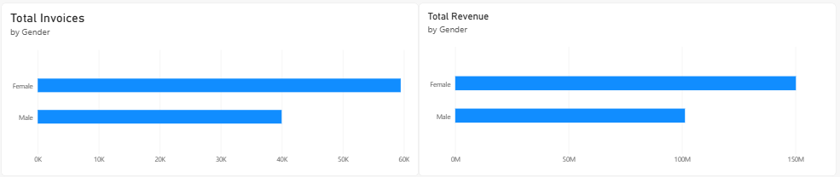

4. Age Insights
- 18–27 years: Highest invoice count (205), revenue ≈ 467K TL
- 58–67 years: Highest revenue (≈ 560K TL) despite fewer invoices.
- Observation: Younger customers shop more often, older customers spend more per transaction.
- Implication: Promotions for younger groups; premium bundles for older groups.

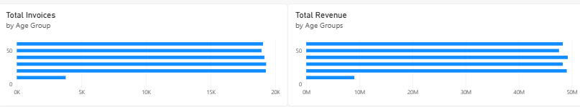

5. Category Distribution
- Clothing: 338 invoices, ≈ 1.05M TL revenue
- Shoes: 103 invoices, ≈ 685K TL revenue
- Technology: 42 invoices, ≈ 493K TL revenue
- Observation: Clothing dominates both in volume and revenue. Shoes and Technology generate high revenue despite fewer invoices.
- Implication: Expand Clothing & Shoes inventory; position Technology as premium.
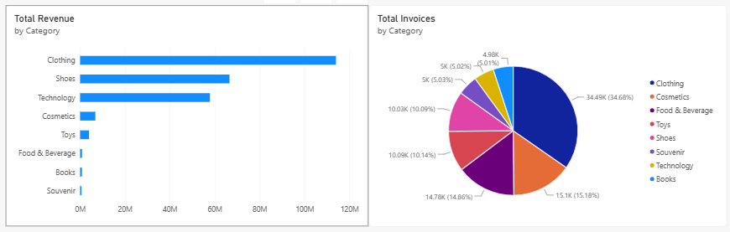

6. Payment Method Insights
- Cash: 420 invoices, ≈ 1.04M TL revenue
- Credit Card: 366 invoices, ≈ 770K TL revenue
- Debit Card: 214 invoices, ≈ 554K TL revenue
- Observation: Cash remains common, but card payments together exceed 50% of revenue.
- Implication: Incentivize digital payments via loyalty points or cashback.
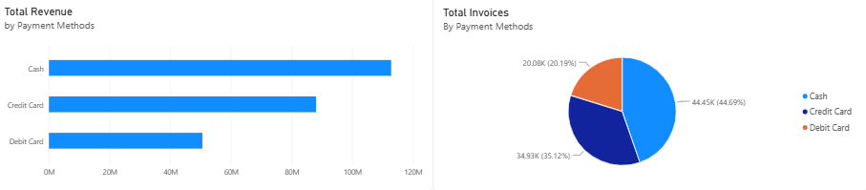

7. Mall Distribution

- Mall of Istanbul: 206 invoices (top performer)
- Kanyon: 195 invoices (second highest)
- Metrocity: 162 invoices
- Observation: Mall of Istanbul and Kanyon are strongest contributors. Category dominance varies: Clothing across malls, Food & Beverage in Kanyon, Toys in Metrocity.
- Implication: Focus marketing campaigns and promotions in Mall of Istanbul and Kanyon.
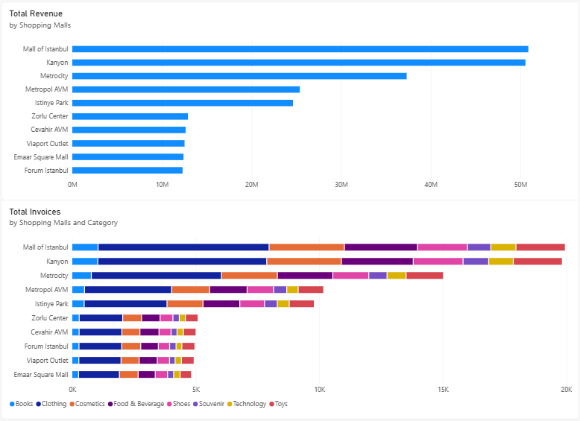

8. Recommendations
- Target promotions toward female shoppers.
- Offer premium bundles for older age groups (58–67).
- Expand Clothing & Shoes inventory.
- Encourage card payments via cashback and loyalty incentives.
- Concentrate marketing campaigns in Mall of Istanbul & Kanyon.

9. Conclusion
This project followed a structured flow:
- Dataset exploration → Pivot table summaries → Visual chart creation → Insight derivation → Recommendations. The analysis shows that customer behavior varies significantly by gender, age, category, payment method, and mall location. Strategic focus on female shoppers, older age groups, high-revenue categories, and top malls can maximize profitability.

